**Write a program to implement the following operations on strings**:

* 1. Read a string, replace string, perform pattern matching, find and replace any occurrences of a pattern

**Student Name: Prince Kumar UID: 20BCS3936**

**Branch: CSE Big Data Section/Group: BD2/A**

**Semester: 03 Date of Performance: 23/08/2021**

**Subject Name: Data Structures Lab Subject Code:** **20CSP-236**

**1. Aim/Overview of the practical:**

**To Write a program to implement various operations on strings.**

**2. Task to be done:**

* Read a string and char from the user
* Search char in string.
* Replace if found
* Print final string

**3. Algorithm/Flowchart:**

Read string str

Get char ch , newch chchachnewcharnewchar

Loop

i <= strrlen(str)

**Y N**

str[i] == ch

==ch

= =ch

**N**

**Y**

Print final string

str[i] = newch

**4. Source Code:**

#*include* <stdio.h>

#*include* <string.h>

#*include* <stdlib.h>

char str[100], ch, Newch;

void *Search*()

{

*printf*("\n Please Enter the Character that you want to Search for : ");

*fflush*(stdin);

*scanf*("%c", &ch);

*for* (int i = 0; i <= *strlen*(str); i++)

    {

*if* (str[i] == ch)

        {

*printf*("%c is present in %s\n", ch, str);

        }

    }

}

void *Replace*()

{

*Search*();

*printf*("\n Please Enter the New Character : ");

*fflush*(stdin);

*scanf*("%c", &Newch);

*for* (int i = 0; i <= *strlen*(str); i++)

    {

*if* (str[i] == ch)

        {

            str[i] = Newch;

        }

    }

*printf*("\n Final String after Replacing All Occurrences of '%c' with '%c' = %s ", ch, Newch, str);

}

int *main*()

{

    int choice = 0;

*printf*("\n Please Enter any String : ");

*gets*(str);

*while* (choice != 3)

    {

*printf*("\n1. Search\n2. Replace\n3. Exit\nEnter your choice: ");

*scanf*("%d", &choice);

*switch* (choice)

        {

*case* 1:

*Search*();

*break*;

*case* 2:

*Replace*();

*break*;

*case* 3:

*exit*(1);

*break*;

*default*:

*break*;

        }

    }

*return* 0;

}

**5. Output:**

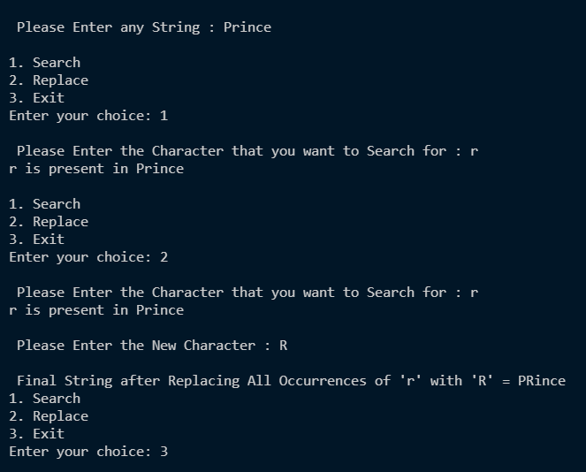

**Learning outcomes (What I have learnt):**

**1.** Able to understand the effective and efficient use of strings in the programming.

**2.** Able to perform various operation on a string.

**3.** Able to search a character in the string.

**4.** Able to replace a character from the string by new one.

**Evaluation Grid (To be created as per the SOP and Assessment guidelines by the faculty):**

|  |  |  |  |
| --- | --- | --- | --- |
| Sr. No. | Parameters | Marks Obtained | Maximum Marks |
| 1. |  |  |  |
| 2. |  |  |  |
| 3. |  |  |  |
|  |  |  |  |